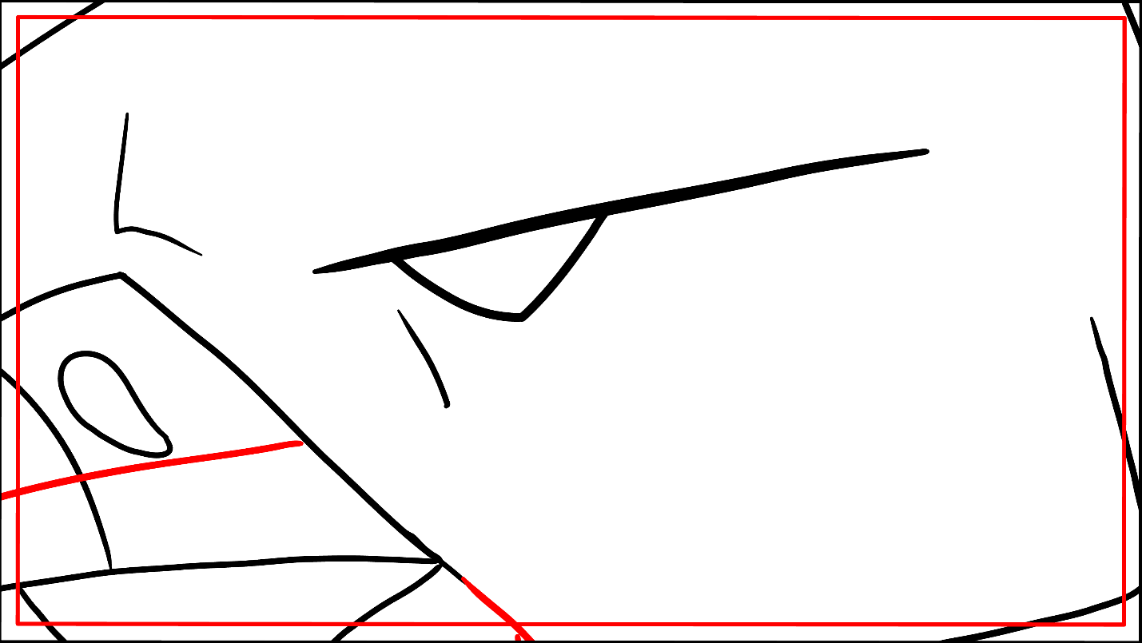
ECU(EXTREME CLOSEUP)- 20

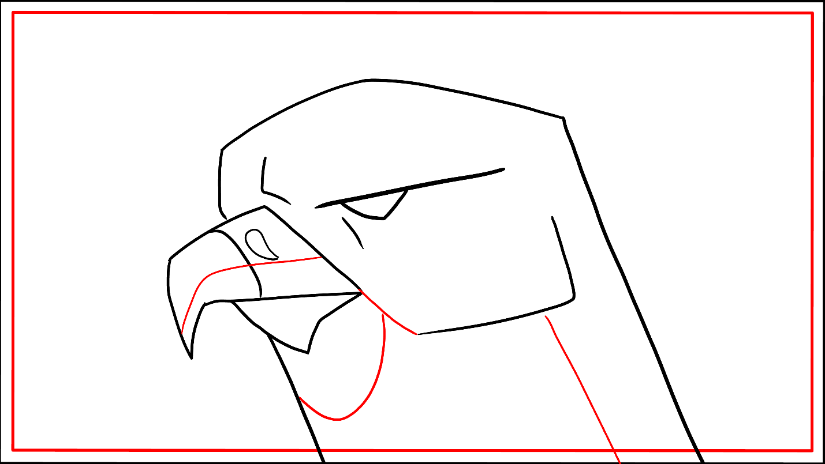
CU(CLOSEUP)- 15
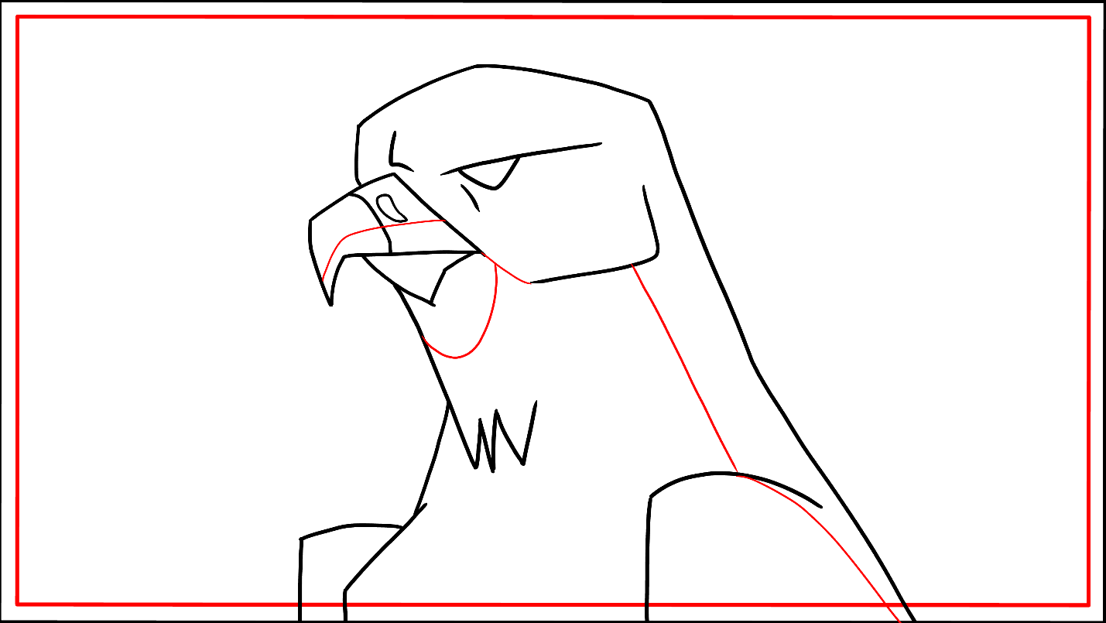
MCU(MEDIUM CLOSEUP)-12

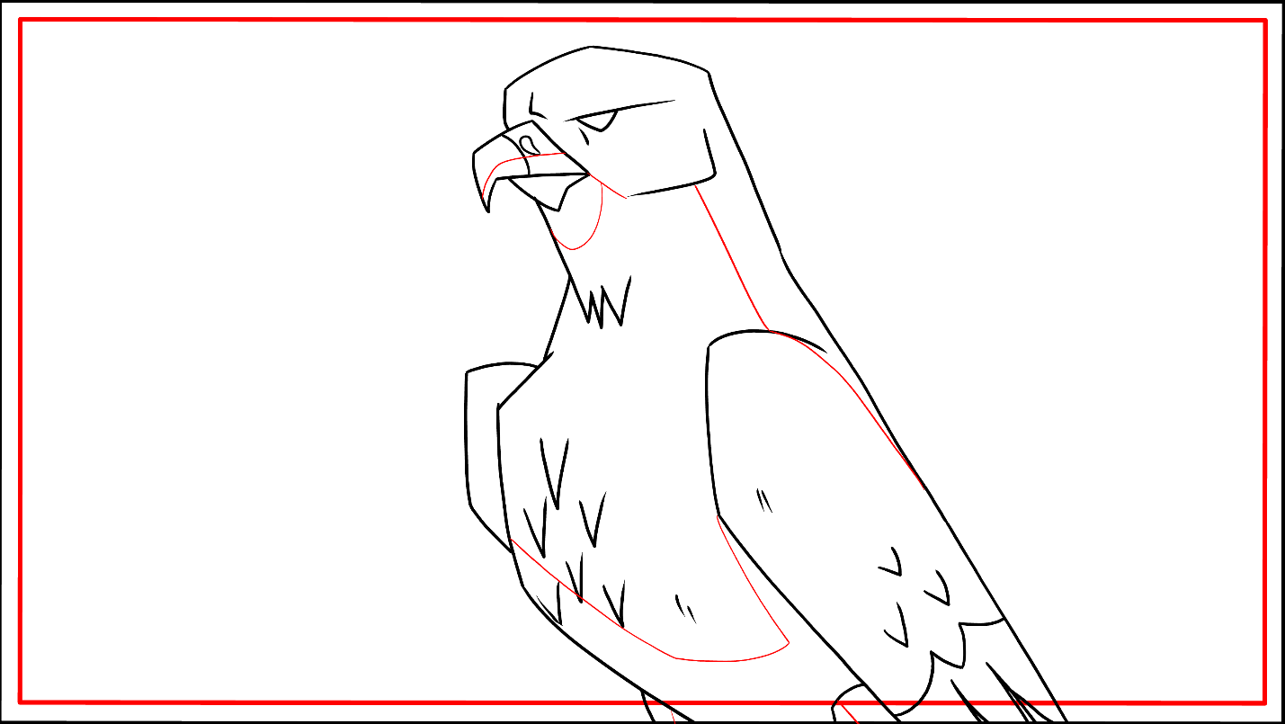MS(MEDIUM SHOT)- 09
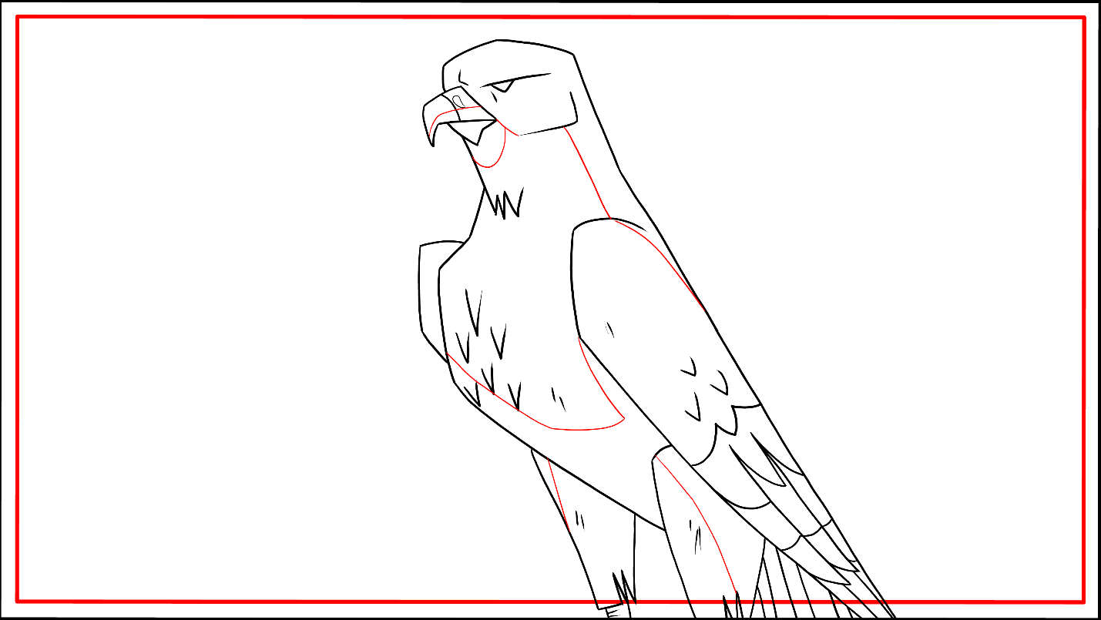
KS(KNEE SHOT)- 07

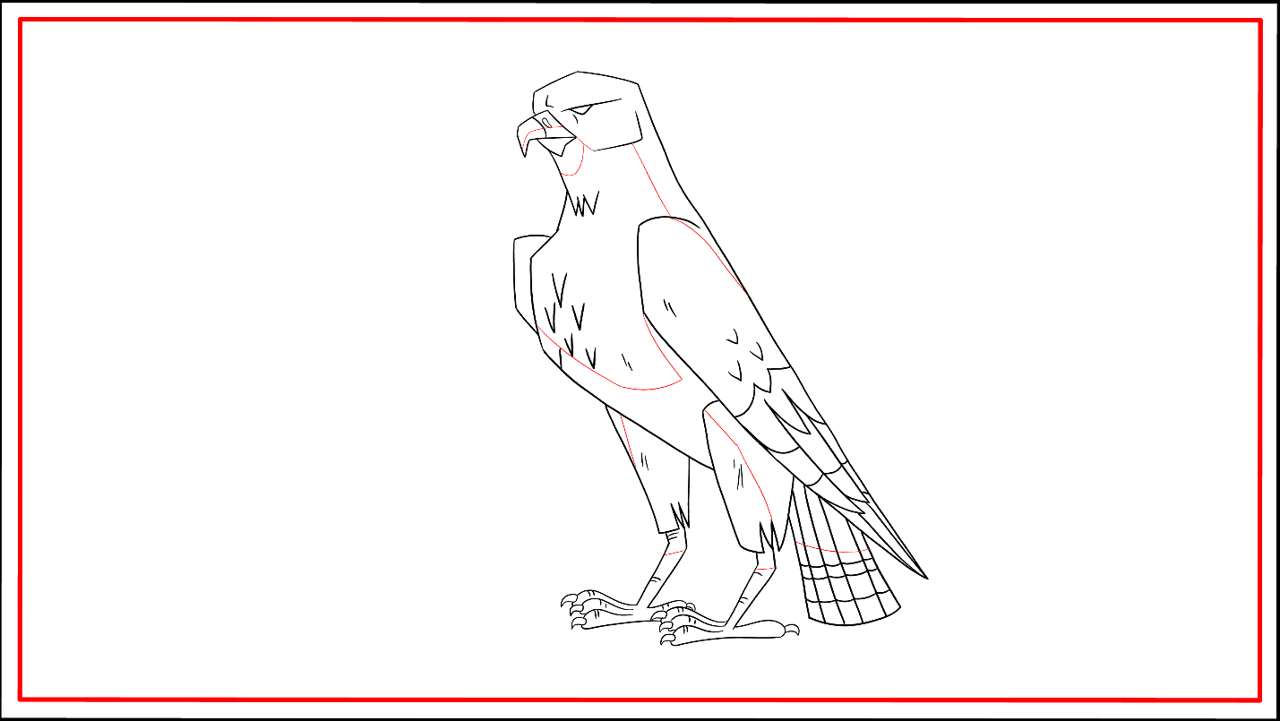
FS(FULL SHOT)-05
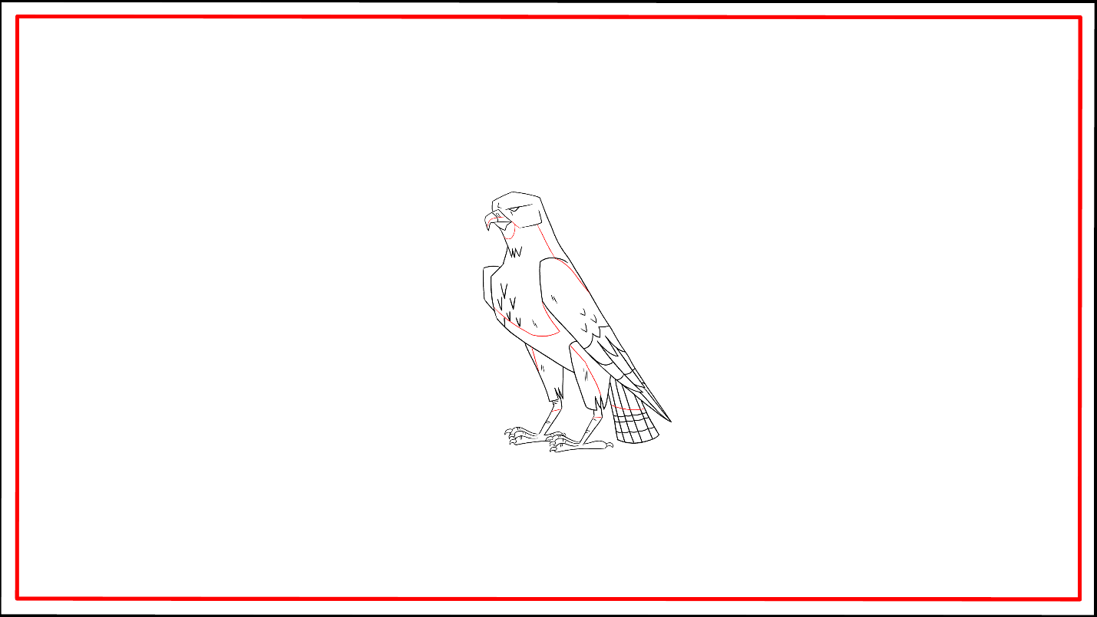
LS(LONG SHOT)-03

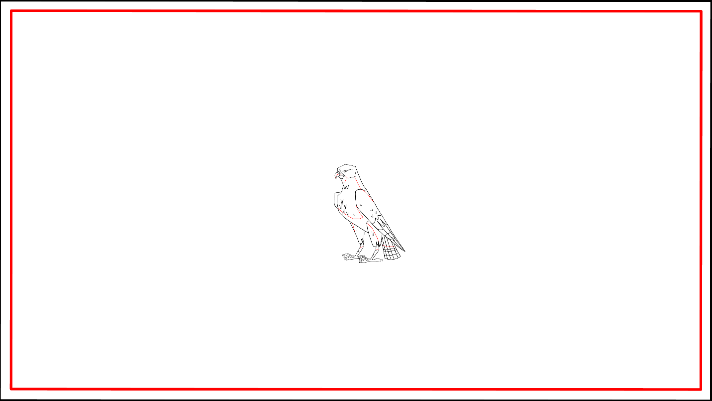
ELS(EXTREME LONG SHOT)-02
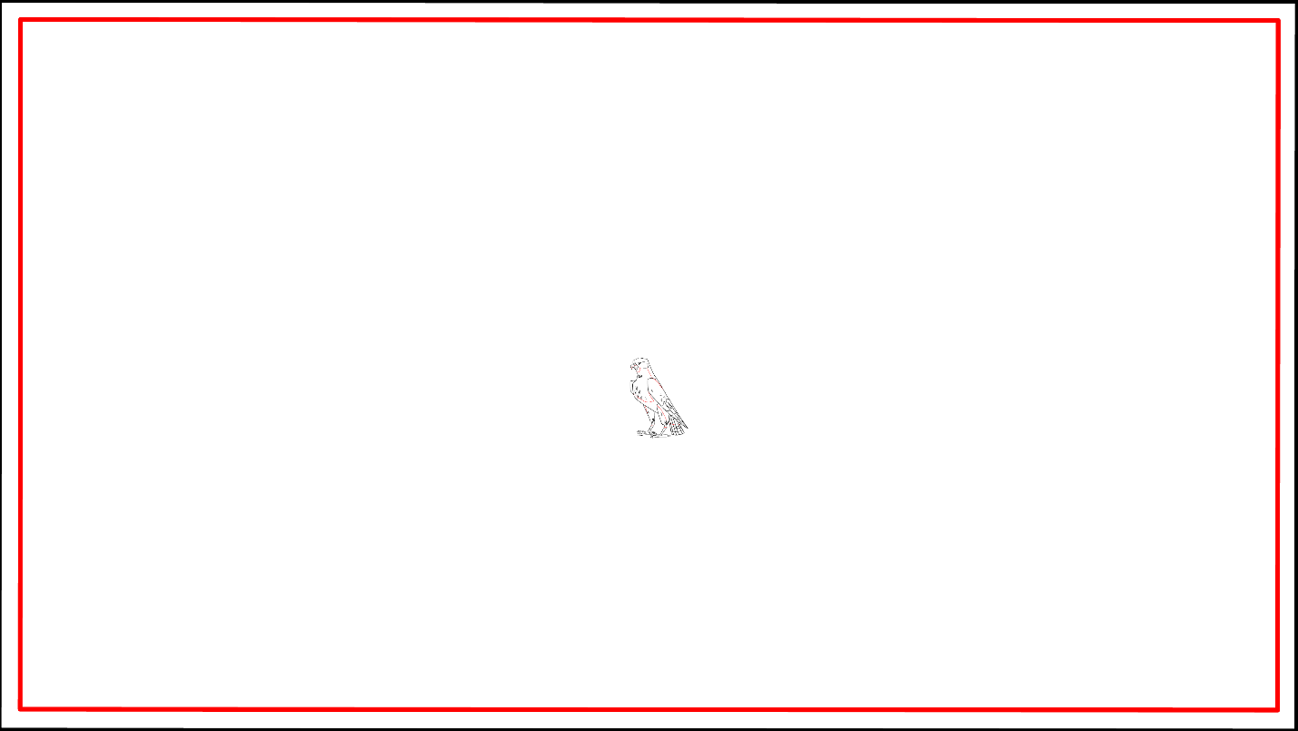MS(MASTERSHOT)-01

