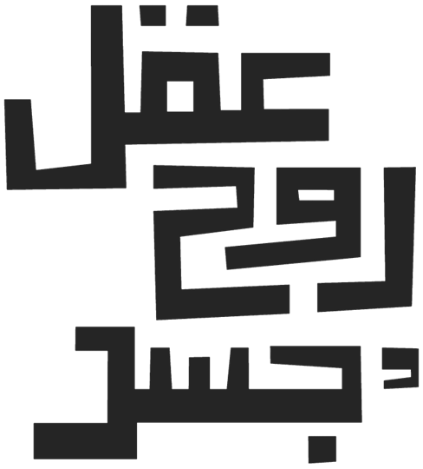

Film Script
Birds Whose Shape is Unknown

The Kadambal birds remain by the tree, watching as Najeer continues carving their portraits into the wide trunk. Hudhud comes and goes, bringing news, confirming that this is indeed the day — and the place.
The moment arrives. Birds from across the land begin circling above the lake, gazing at their reflections in the shining surface below. A breathtaking scene — the sky filled with birds, their mirrored images rippling below — like a living painting. Different birds are shown looking at their reflections on the lake. They see their reflections and feel happy. Then we cut to the main characters:
Babaghawiya
curious
“The time has come?
Shall we go see ourselves?”
Hudhud
with wisdom
“Search within yourself.
We no longer need that…
We have already found ourselves.”

But the Kadambal birds don’t move. They’re still beside the tree, content to watch Najeer finish his carvings. He completes the last portrait — a detailed image of Habari. Then, without a word, he removes the scarf he once wore around his head — once used to ease his pain — and throws it into the sky, free. He continues carving.

When he finishes them all, Habari steps closer.
Habari
Softly
You carved all of us so beautifully...
But who will carve your portrait?
Najeer smiles, proud… but there’s a trace of quiet sadness.
And just then, another woodpecker lands beside him on the same branch. He looks at Najeer, then he begins to carve Najeer’s portrait into the tree.

