Hello everyone,
I would like to share with you the writers' feedback for the animatic. Instead of waiting for the client and delaying the episode further, I'm sharing their notes now.
The most important feedback is about two shots that need to be amended:
- Harbari: We need to clearly show how he makes the pattern on the sand. Like mentioned in the script, here is an example:
I think you also implemented the pattern in your concepts.
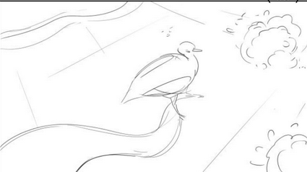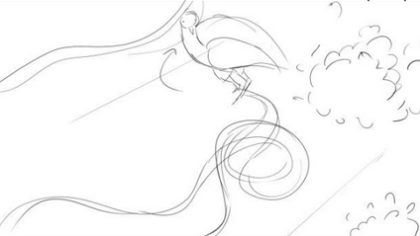
- Najeer: We need to show that he has a headache, which explains why he's always in a bad mood and wears a headband.
These comments are available in Frame.io for your review. There are also other comments regarding the episode itself, and I have translated the most relevant ones for the animatic.
As I mentioned before, I'm currently working on editing the animatic to shorten the episode. At the moment, my cut is around 12:34, but I'm still working on it. I will share this edit later, either once I finish it or after we receive the client's feedback and/or approval. The edit mainly involves applying the suggested cuts in Frame.io and tightening certain dialogue to improve pacing.
For now, please proceed with amending the two shots highlighted by the writers. Once I share the edited animatic, please incorporate those amended shots into it. I will also send you the final voice files for each character once the edit is complete, so we can have everything finalized and ready for production.
Thank you,

